Annual Report

2018-2019

The Society Of Research and Development(SORAD)

VPO, Village-Sahad,

Jhunjhunu, Rajasthan, 333036

E-mail: soradsociety2007@yahoo.com

M: 8114461928

**ORGANIZATION AT A GLANCE**

|  |  |  |
| --- | --- | --- |
| 1. | Name of the organisation | The Society Of Research and Development(SORAD) |
| 2. | Office Address | Village-Sahad, Buhana jhunujhunu, Rajasthan-333036 |
| 3. | Chief functionary Important Contact Number | Mr. Prem Prakash Verma Secrertary |
| 4. | Status of the Organization | A Non-Government Voluntary Social Organization, Register under Society Registration Act 1958 Govt. of Rajasthan |
| 5. | Area Operation | Rajasthan state |
| 6. | Date of Establishment | 1958 |
| 7. | Registration No. | 15/Jhu/2008-09 |
| 8. | Date of Registration | 03.05.2008 |
| 9. | Name of the Bank General | Axis Bank |
| 10. | E-mail | [soradsociety2007@yahoo.com](mailto:soradsociety2007@yahoo.com) , soradsociety2007@gmail.com |
| 11. | Total Member | 7 |
| 12. | Pan No | AABAT8748G |
| 13. | Niti Aayog/Ngo Partnership System Unique No | 2019/0231798 |

The presenting Annual Report of this organization The Society Of Research and Development(SORAD)was formally registered under Rajasthan Societies Registration Act 1958, Registration no 15/Jhu/2008-09 on Dated 03.05.2008 . The member of the society largely consists of volunteers who are professionals, teachers, social, Legal Awareness Programme and activists. The society has been active in Rajasthan. The following are the main approaches based on which the strategies and programme of the Society are designed.SORAD help the poor for education, and help them through social activity and through of fund all poor people and student in all over in Rajasthan. The main activities of the organization are following.

1) Student Welfare

2) Health Checkup Camp

3) Education Awareness Programme

4) Sports & Games Programme

5) Disability Programme

7) Free Coaching Programme

8) Cultural Development Programme

9) Road Safety Awareness Programme

10)Environment Programme

11)Social welfare programme

12)Women and Child Development Programme

Other Objects are:- Water Harvesting,and Water management ,Work for youth,Work for child labour prevention,Animal welfare,Medical and Bio diversity,Work for climatic changes,Consumer awerness,Work for Natural Disaster management,Rural Library and Litracy Programme,Sanitation and Health and malnutrition,Labour welfare,Games orgnazing programmes in rural areas,Plantaion in rural Urban areas,

1. Student Welfare

The Society of Research Ans Development has to impart many kinds of learning to women and Child like the learning of concepts, rules and principles, aesthetic discrimination etc, through problem solving and other skills. Inherent to the acquisition of these Kinds of learning are the development of the right of the right attitude and values. It is important to realize that values can’t not be entirely taught as a subject in school and the inculcation of values can do it be left only to the moral science or value education teacher. Every teacher of this society is equally responsible for this undertaking inside and outside the classrooms, for value education. There are many procedure & influences through which a child forms its attitude and values. The school & teacher is certainly one of the most important of these influences and it’s worthwhile to find out the ways in which a school can most effectively carry out this duty. A scholarship has announced for Poor talented boyes and girls in Govt.Higher Secondary school Nalpur ,Teh.-khetri,district Jhunjhunu and Decided to donate School uniform also.

1. Health Checkup Camp

Adequate medical facilities are not available in all parts of the state, particularly in remote areas, besides being costly. Primary Health Centers are unable to cater to the needs of all peoples. A large section of poor people from rural as well as urban areas are unable to afford the high costs of treatment keeping this in mind, the Trust conducted a free medical camp with the co-operation of local doctors. People from nearby villages, mostly poor came to the camp for check-up and treatment including medicines free of cost. More than 100 patients including old and children suffering from various elements received free about and medicines

1. Education Awareness Programme

Camps were organized for Literacy Awareness in different places. The poor and illiterate beneficiaries were made aware about the importance of education and information was provided on how and where they can excess free education.

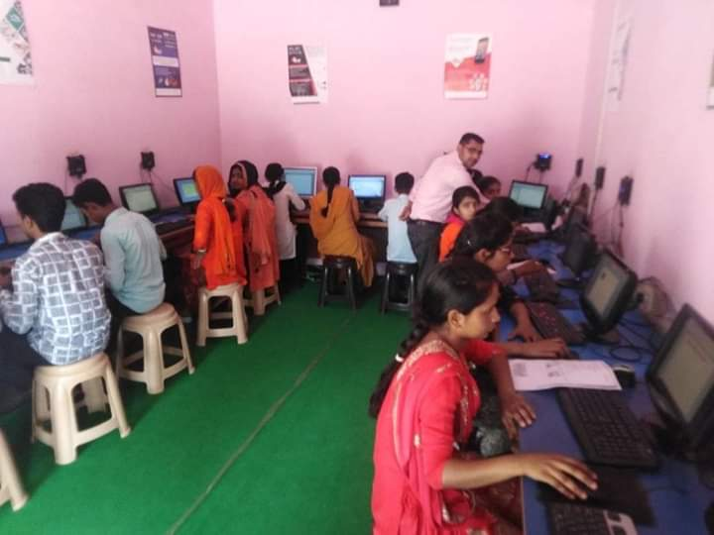

1. Sports & Games Programme

The society also promotes various games and sports. The people are encouraged to take part in various sports and tournaments.

1. Disability Programs

Organized awareness and sensitisation program for the general population and for disabled people through focus group meetings.

1. Free Coaching Programme

The Association has been conducting Free Coaching for course with the miscellaneous funds of the society on educations to almost 200 Beneficiaries by expert staffs of the organization. The management group of SORAD expressed their concern amidst most enchanting cheers to concentrate their entire purpose for implementing the most outstanding and spectacular concept of starting free education for the year from its own fund.

1. Cultural Development Programme

SORAD aims to promote high value of humanity, brotherhood, peace and harmony among people through cultural development activities. It works to create an environment of communal harmony and national integration in its working areas. The organization also organizes cultural programmes to promote peace messages. The organization also organizes cultural events among children and adolescents to make them understand the diversity in culture in India. We also conduct awareness talks among students on the relevance and significance of different festivals of different festivals of all religions. It helps in creating a harmonious atmosphere among students as it starts knowing the importance and significance of all religions, which he/she does not belong

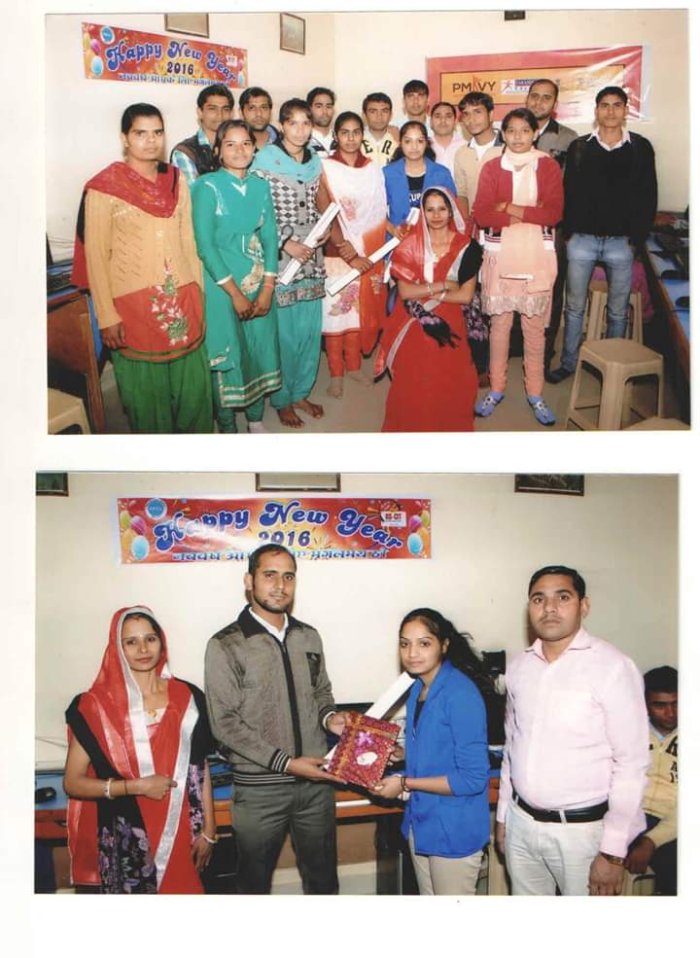

1. Road Safety Awareness Programme

The society organizes road safety awareness programme for children, women, and others. People, in search of livelihood, migrate to the cities from the target areas where the society works. In villages people are not so aware about the traffic rules and road safety norms. It found very important to make people aware about the road safety norms. Keeping this in mind Road Safety.

1. Environment safety programme

SORAD main aims to take care of natural resources use them on sustainable basis, these resources must be preserved and developed. **World Environment Day** (**WED**) is celebrated on 5 June every year . Our society has been raising awareness, supporting action, and driving changes for the environment.

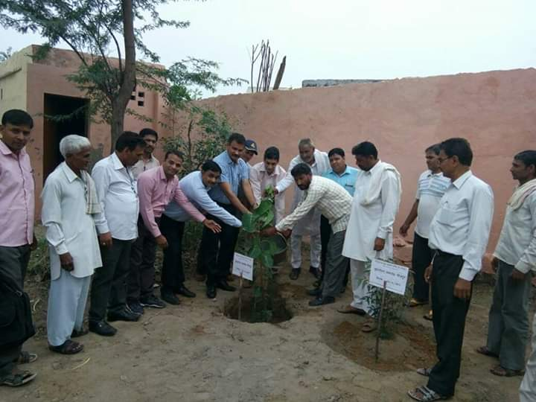

1. Social Welfare programme

Societies formulates plans, policies and programmes, guides and co-ordinates the efforts of both governmental and non-governmental organizations in the field of women and child development. The programme of women and child development promotes and assists the voluntary sector significantly in the implementation of government policies and programmes for women and children. The focus of the Department is the all-round development of women and children and empowerment of women.

**The Society Of Research and Development**

**village-Sahad, Jhunjhunu, Rajasthan, 333036**

**LIST OF TRUSTEE**

|  |  |  |
| --- | --- | --- |
| **S.no** | **Name of Trustee** | **Designation** |
| **1** | **Prem Prakash Verma** | **Secretary** |
| **2** | **Vikash** | **Chairman** |
| **3** | **Sunita Verma** | **Treasurer** |
| **4** | **Suresh kumar** | **Member** |
| **5** | **Ranveer Singh** | **Member** |
| **6** | **Manish Kumar** | **Member** |
| **7** | **Pawan** | **Member** |

**The Society of Research and Development ,Village-Sahad**

**Buhana,District- Jhunjhunu**

**Income and Expenditure Account**

|  |  |  |  |  |
| --- | --- | --- | --- | --- |
| **S.NO** | **Financial Year** | **Income & Expenditure** | **Surplus** | **Balance Sheet** |
| **1.** | **2018-2019** | **1,052,400.00** | **1,038** | **1,52,371.00** |
| **2.** | **2017-2018** | **834,912.00** | **877** | **1,91,951.00** |
| **3.** | **2016-2017** | **634,772.00** | **2418** | **1,92,578.00** |

Annual Report

2017-2018

The Society Of Research and Development(SORAD)

VPO, village-Sahad,

Jhunjhunu, Rajasthan, 333036

E-mail: [soradsociety2007@yahoo.com](mailto:soradsociety2007@yahoo.com)

M: 9250400366

**ORGANIZATION AT A GLANCE**

|  |  |  |
| --- | --- | --- |
| 1. | Name of the organisation | The Society Of Research and Development(SORAD) |
| 2. | Office Address | Village-Sahad, Buhana, jhunujhunu, Rajasthan-333036 |
| 3. | Chief functionary Important Contact Number | Mr. Prem Prakash Verma Secrertary |
| 4. | Status of the Organization | A Non-Government Voluntary Social Organization, Register under Society Registration Act 1958 Govt. of Rajasthan |
| 5. | Area Operation | Rajasthan state |
| 6. | Date of Establishment | 1958 |
| 7. | Registration No. | 15/Jhu/2008-09 |
| 8. | Date of Registration | 03.05.2008 |
| 9. | Name of the Bank General | Axis Bank |
| 10. | E-mail | [soradsociety2007@yahoo.com](mailto:soradsociety2007@yahoo.com) |
| 11. | Total Member | 7 |
| 12. | Pan No | AABAT8748G |
| 13. | Niti Aayog/Ngo Partnership System Unique No | 2019/0231798 |

The Society Of Research and Development(SORAD)is a non – government and non-profit organisation committed for sustainable community development progrmmes through participatory and applied research. It has its headquarters at Rajasthan, and is primarily concerned with the overall social, economic, environment, health, gender and cultural development of the disadvantaged people at the grass roots level as part of the poverty alleviation programme and gender empowerment. It was established in the year 2008 with the initiative of a small group of young social scientists, medical persons and social workers dedicated for the betterment of the people

1) Education, Training and Capacity Programme.

2) Health Awareness Camp.

3) Sanitation and Hygiene.

4) Environment Programme.

5) Research and Documentation.

7) Bio Diversity Programme.

8)Humans rights.

➢ Education, Training and Capacity Building Programme

Education, as well all know, is a powerful catalyst to socio-economic change and is the quickest way to make a productive break through. India has out of school children outnumber those who go to school. SORAD is working to bridge this gap with the motto "literacy for all". We have established education centre's in the community that aim to maintain children to back into school. SORAD is working for basic education through non-formal education programme among the disadvantaged people, since this is the quickest way to make a productive break through. Out of school children outnumber those who go to school. These include a) school drop outs b) working children c) children especially girls who cannot attend formal school because they attend sibling or household chores. Keeping this in view, we have established education centre’s in the community that aim to maintain children to back into school. The strategy being followed in the education programme by the ISARD volunteers include use of multifarious tools like awareness campaigns, surveys and studies, counselling and setting up of Remedial Education Centres.

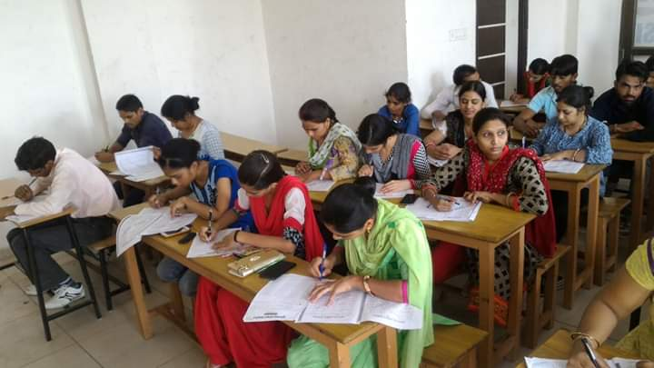

➢ Health Awareness Camp.

**SORAD** is working towards ensuring timely, effective and near-the-patient healthcare services to the community. The project seeks to tap available recourses to avail to the community to prevent and reduce the incidence of diseases  and morbidity and mortality. Interventions are also aimed at instituting measures for improved nutrition and mother and child care systems. Health Camp is one such special initiative of **SORAD** to provide health care services to meet the immediate health care needs of the marginalized community in remote rural areas and. curative, preventive, promotive and referral, to a large number of people in selected intervention areas.

➢ Sanitation and Hygiene.

The goal is this programme to promote and disseminate point-of-use water treatment methods at household level and improve hygiene practices of the final beneficiaries to reduce child mortality and improve the overall health situation in **SORAD** programme some area in Rajasthan. The vision is to ensure all families in the programme area an access to safe and affordable drinking water.

➢ Environment Programme

Modernization and industrialization of economies has marked a shift in the human and natural relationship from stewardship to that of exploitation of natural resources and environmental pollution. While the natural resource streams have been degraded by overuse, misuse and abuse by societies worldwide, their outputs have resulted in widespread air pollution, water contamination, land degradation and generation of wastes. The rate of creation of these residual affluent and wastes in the natural surroundings far outreaches the regenerative and assimilative capacities of ecosystems. While scientific knowledge informs that as nations and societies develop their capacities to tackle environmental issues enhances, but SORAD believes that rapidly growing economies should be pro-active in dealing with environmental

risks and impacts. In addition, energy access and security to all should be channelled through clean and safe energy systems. As such, SORAD works in the areas of natural resource management, ecological modelling, carrying capacity, environmental economics, energy analysis and audit, renewables and energy efficiency, environmental impact assessments and pollution abatement at regional, sub-regional and local scales.

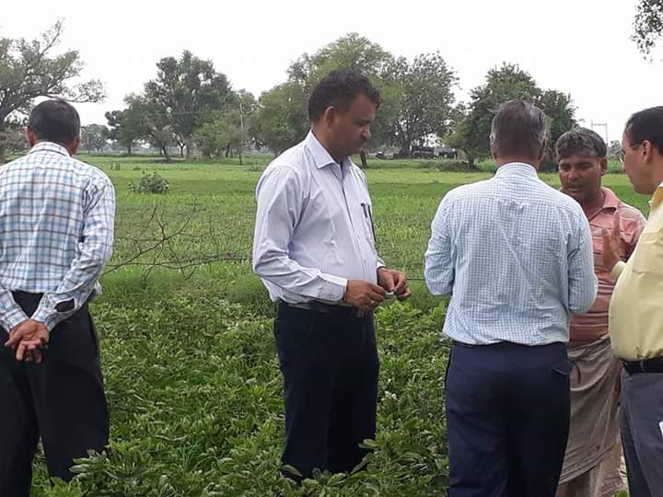

➢ Research and Documentation.

Research and documentation is one of the major focus areas of **SORAD,** as it gives proper understanding of social issues. Since inception we followed the path of research and documentation which helps in evolving us to the present status. On the basis of grass root experience & need of the community **SORAD** plans to development activities in the areas.

➢ Bio Diversity Programme

Conservation of biodiversity has always been an objective of environment education. SORAD has expertise in and has done a wide range of activities in this area. It coordinated the 'Education, Awareness and Training' Thematic Working Group of the National Biodiversity Strategy and Action Plan. Several of its Ecodevelopment Programmes looked at biodiversity conservation as a major thrust.

➢ Humans rights

Many human rights NGOs also include, at least as part of their activities, some type of public awareness or educational work. Realising that the essence of their support lies with the general public, SORAD will often try to bring greater knowledge of human rights issues to members of the public. A greater knowledge of these issues and of the methods of defending them is likely to engender a greater respect and this, in turn, will increase the likelihood of being able to mobilise support in particular instances of human rights violations. It is that support, or potential support, that lies at the base of the success of the Community in improving the human rights environment.

Annual Report

2016-2017

The Society Of Research and Development(SORAD)

VPO, village-Sahad,

Jhunjhunu, Rajasthan, 333036

E-mail: [soradsociety2007@yahoo.com](mailto:soradsociety2007@yahoo.com)

M: 8114461928

**ORGANIZATION AT A GLANCE**

|  |  |  |
| --- | --- | --- |
| 1. | Name of the organisation | The Society Of Research and Development(SORAD) |
| 2. | Office Address | Village-Sahad, Buhana, jhunujhunu, Rajasthan-333036 |
| 3. | Chief functionary Important Contact Number | Mr. Prem Prakash Verma Secrertary |
| 4. | Status of the Organization | A Non-Government Voluntary Social Organization, Register under Society Registration Act 1958 Govt. of Rajasthan |
| 5. | Area Operation | Rajasthan state |
| 6. | Date of Establishment | 1958 |
| 7. | Registration No. | 15/Jhu/2008-09 |
| 8. | Date of Registration | 03.05.2008 |
| 9. | Name of the Bank General | Axis Bank |
| 10. | E-mail | [soradsociety2007@yahoo.com](mailto:soradsociety2007@yahoo.com) |
| 11. | Total Member | 7 |
| 12. | Pan No | AABAT8748G |
| 13. | Niti Aayog/Ngo Partnership System Unique No | 2019/0231798 |

**Society of Research & Development (SORAD)** is a non-profit non-governmental organization committed for sustainable community development through participatory and applied research, capacity building, and issue based interventions having its network among urban slum dwellers and among people of rural and tribal areas with particular emphasis on education, health and hygiene, environment, community and gender empowerment ,agriculture and rural development and general social upliftment for the socially disadvantaged people at the grass root level. SORAD came into existence in **2008** by a group of professionals and social workers to use their expertise to build a just society, formally registered under Rajasthan Societies Registration Act 1958, Registration no 15/Jhu/2008-09 on Dated 03.05.2008 . The sole objective of the founding members is to assist in the empowerment of the disadvantaged children, women, youth and the aged people in identifying and achieving their aspirations in terms of healthy living & overall prosperity at the individual and community levels. The main activities of the organization are following.

1) **Life Skills education for Adolescent Girls**

2) **Training and Capacity Building**

3) **Training of Peer educators and Outreach Workers**

4) Health Awareness Camps

5)**Integrated Watershed Management Programme (IWMP)**

6) **Climate and Biodiversity Conservation**

7) Skill Development for women.

8) Nutrition support to HIV/Aids infected people.

9) Sanitation support for disabled people

➢ **Life Skills education for Adolescent Girls**

This programme is based on the evidence that literacy and education improves the health and social status of women and girls. The programme addresses the special needs of adolescent girls and equips them with life skills for a better quality of life. The primary intervention is life skills course for adolescent girls with a special focus on out-of-school and working girls. The programme also focuses on sexuality education, anemia prevention and improvement of the reproductive health of adolescent girls.

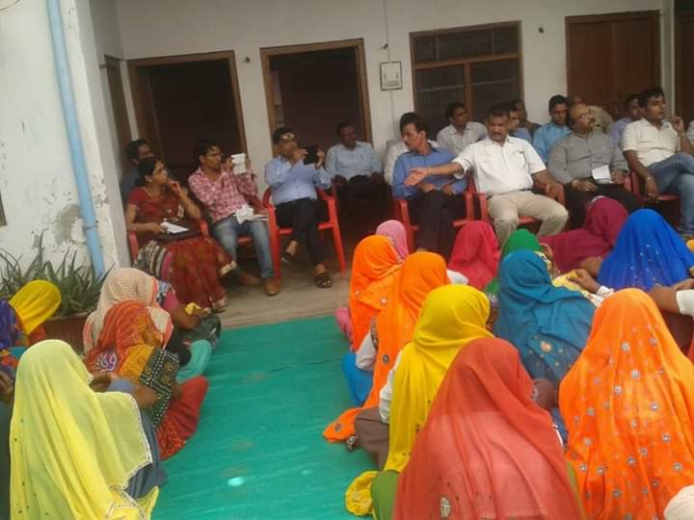

➢ Training And Capacity Building

The capacity building component of the project envisages training programmes for groups with an aim to enhance their understanding the dynamics of group formation, group management, financial management and federation building and to build their capability to identify and analyze problems, to apply skills and resources to solve them in a sustainable manner. The project functionaries, Community coordinators are regularly trained to develop their capacities to shape as full fledged development professionals. They are trained on development and poverty, PRA techniques and are especially sensitized to work with the poor. Some of the skill trainings are: Workshop on an induction & social mobilization processes. Experience sharing and skill development, Gender training needs assessment, Gender Sensitive CIF guidelines, TOT on social mobilization processes, Baseline, process monitoring and MIS, Audit training, Convergence with departments, Exposure visits and IG & Micro-finance sub projects

➢ **Training of Peer educators and Outreach Workers**

Peer education enlists members of a specific group to effect behavior change among their peers. The success of the peer education program is in creating a supportive environment for improving the health conditions of their peers and they belong to the same community. The PEs is from the same communities as the HRG. It was observed during the programme that the female PEs were more accessible to the target group. However, each of the PEs extended support to their clients in giving information, providing condoms, referring to ORWs and accompanying the clients to the STI clinic to the places of referrals. Regular weekly meetings were held with the PEs for training, review the performance and orienting them in: Basic communication skills during interactions, Myths and myth conception about sex and, sexuality, Basics of STI/AIDS.

➢ Health Awareness Camps

Health Camp is one such special initiative of **SORAD** to provide health care services to meet the immediate health care needs of the marginalized community in remote rural areas and. curative, preventive, promotive and referral, to a large number of people in selected intervention areas.  
  
Apart from this we are organizing awareness camps on issues like **alcoholism, drug abuse, anemia, malnutrition, TB and HIV & AIDS** .Keeping in this view , **SORAD** has taken up a number of programme covering the entire continuum of needs of the vulnerable groups from HIV prevention .The prevention programmes include the essential components of behaviour change through BCC and interpersonal communication session, peer led facilitation ,condom promotion and sending people to right place/ health centre for clinical services for treatment of RTI/STI.

➢Integrated Watershed Management Programme(IWMP)

The main objectives of the IWMP are to restore the ecological balance by harnessing, conserving and developing degraded natural resources such as soil, vegetative cover and water. The outcomes are prevention of soil erosion, regeneration of natural vegetation, rain water harvesting and recharging of the ground water table. This enables multi-cropping and the introduction of diverse agro-based activities, which help to provide sustainable livelihoods to the people residing in the watershed area. ISARD was appointed by IRG-IWMP, New Delhi to conduct the baseline survey, data entry and data analysis of this project.

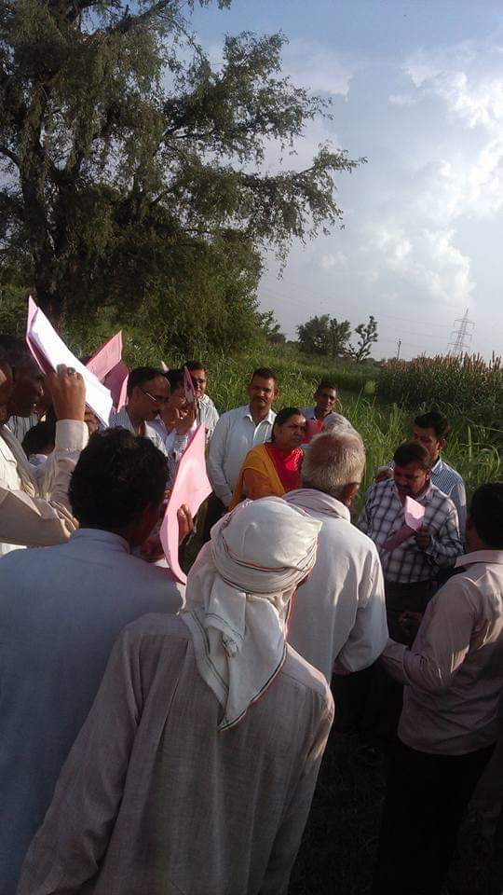

➢ **Climate and Biodiversity Conservation**

One of SORADs activity is to raise the environment awareness level of the entire society, through campaigns on environmental practice. In order to motivate the people to protect the environment, SORAD has taken up environment conservation initiatives, predominantly implemented through self-help groups. The main aim of the programme is to protect the people from global warming situation. The major programme activities that are being carried out include: Awareness raising for benefit of plantation, Circulation of information and communication materials, Awareness for environmental health, Research & Documentation. SORAD has developed a concrete programme mainly for forestation and water conservation. The activities therein include awareness campaigns,

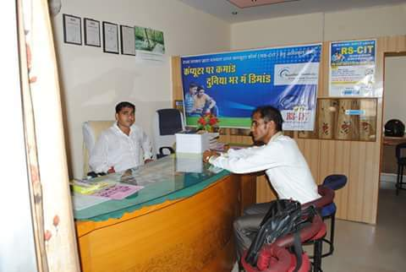

➢ Skill Development for women

Promote skills among the women and adolescents on locally viable trades Problem: We “progressive” women may not like it, but the realities in rural areas are harsh and rigid. Girls aren’t encouraged to pursue jobs and dreams beyond their village, because understandably, their safety is an issue. For parents to confidently send their daughters even to the nearest town for anything – better education, jobs – is a big deal. The rural hinterlands, picturesque as they are from a road trip in a car, are not accessible by bus or other public transport. Even if they are, there is never an assurance that the roads are safe for young women. Many of these girls are content in their little worlds, not really caring for an education.

➢ Nutrition support to HIV/Aids infected people.

Strengthen the immunization system and increase the life span of HIV/Aids infected people Problem: HIV does not only affect individuals, but the whole family. The financial burden of HIV can be enormous on a family, especially if several family members are sick. Many HIV patients also report losing their livelihood after being diagnosed with HIV. The combination of decreasing income and increasing health care costs may prevent the family living with HIV from getting their basic needs met. The epidemic disrupts livelihoods, affecting productive activities and increasing the household dependency ratio (due to disease and orphans), and resulting in increased food insecurity and malnutrition.

➢ Sanitation support for disabled people

Create facilities to lead a normal life as other well-beings Problem: Disabled people are among the poorest, most vulnerable and marginalized groups in society. The impact of disability is usually felt by the whole family, through lost income, treatment costs and the reduced well being of everyone. Disabled people have the least access to these services, which compounds their isolation, poor health and poverty. A lack of accessible sanitation facilities can have a double impact. For example, in communities where women defecate at night, moving around in the dark is extra hazardous for a disabled woman.